**Human and Computer Interaction Laboratory**

**Assignment 5**

**Name**: Milind Kedare **Batch**: K11

**Roll number**: 33326 **Date of Submission**: 30/10/2021

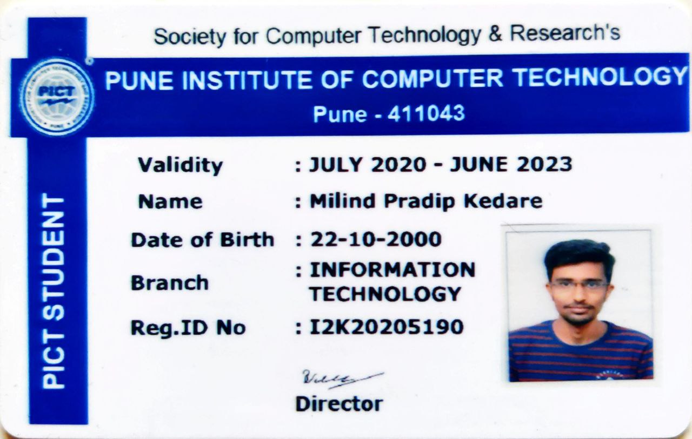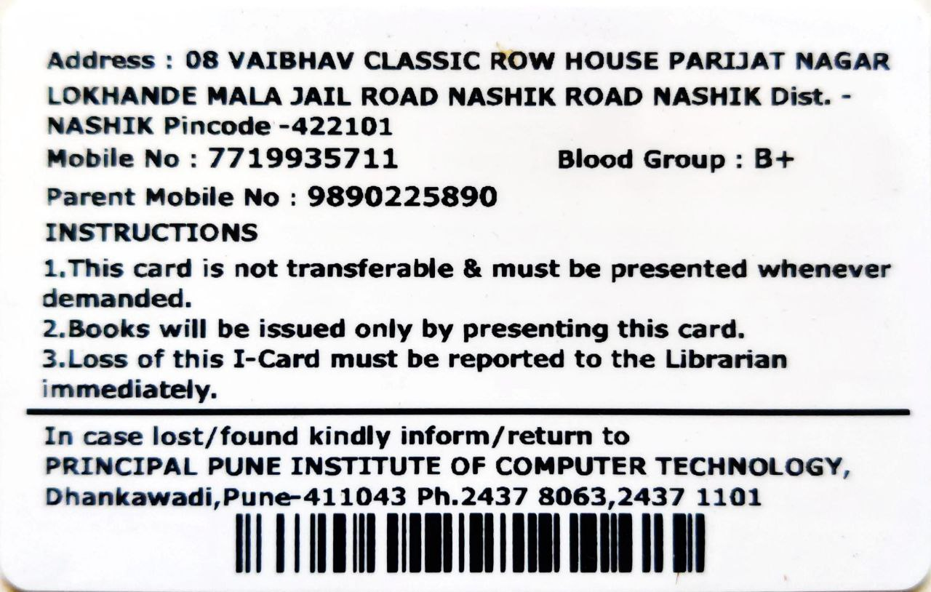

Group Members:

1. Aditya Kangune (33326)

2. Vedant Deshpande (33313)

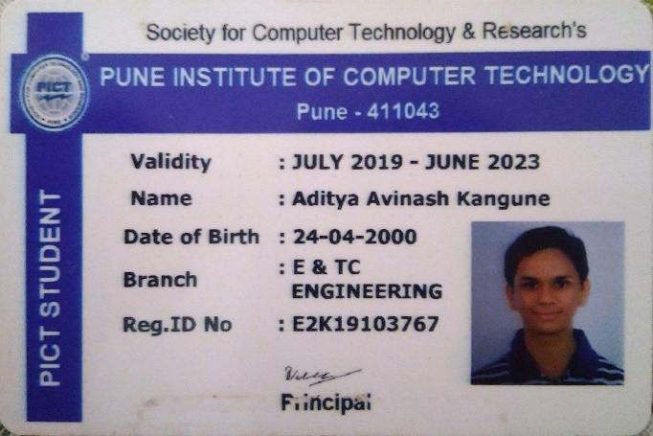 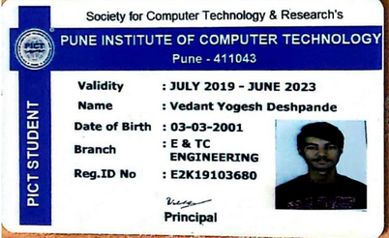

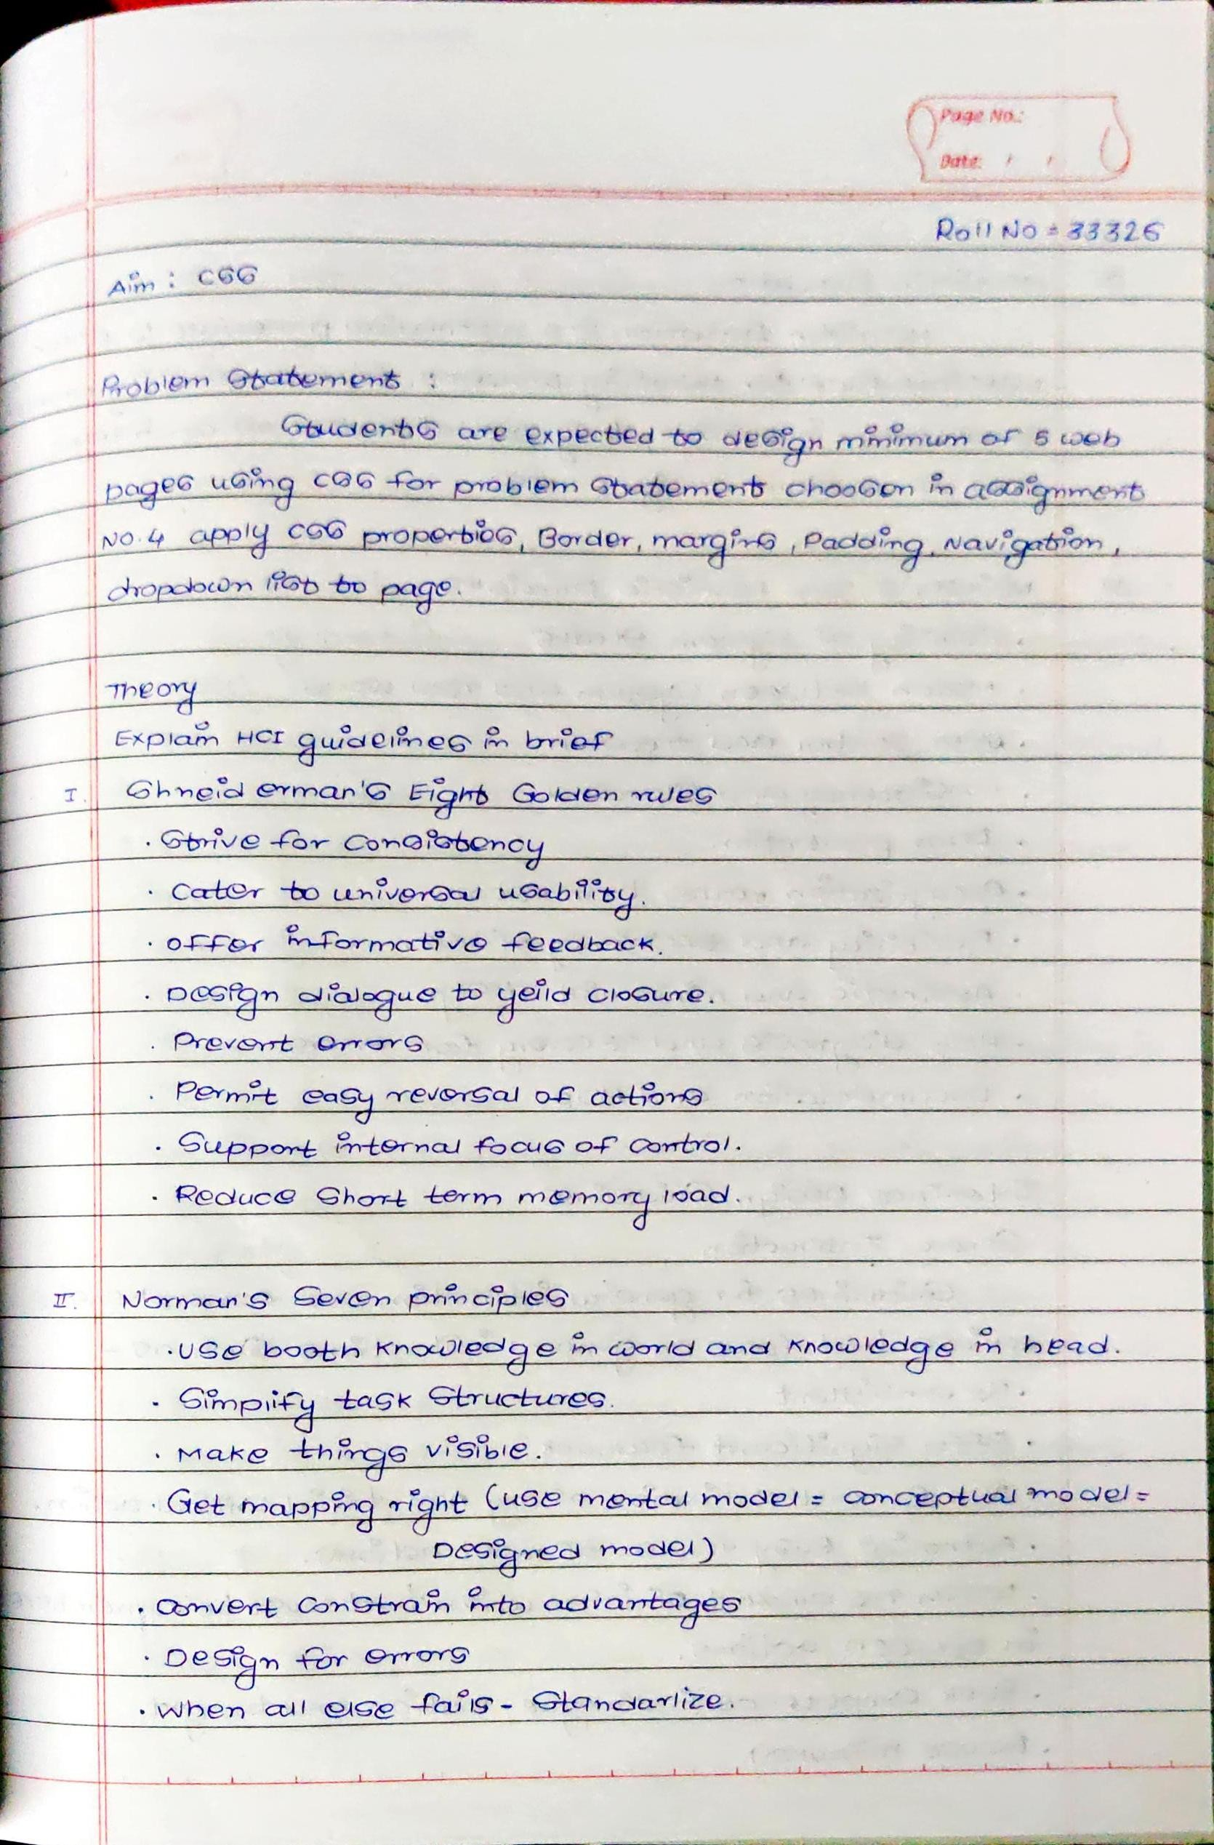

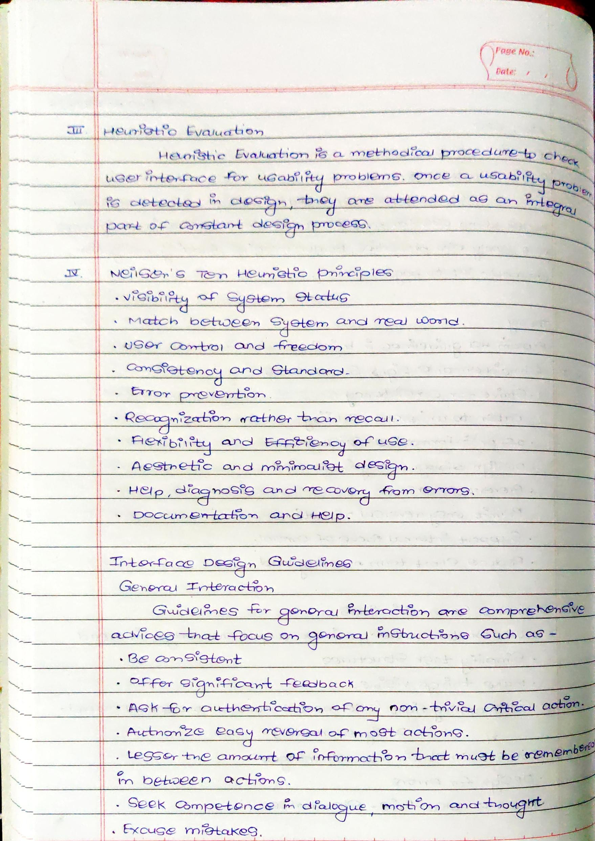

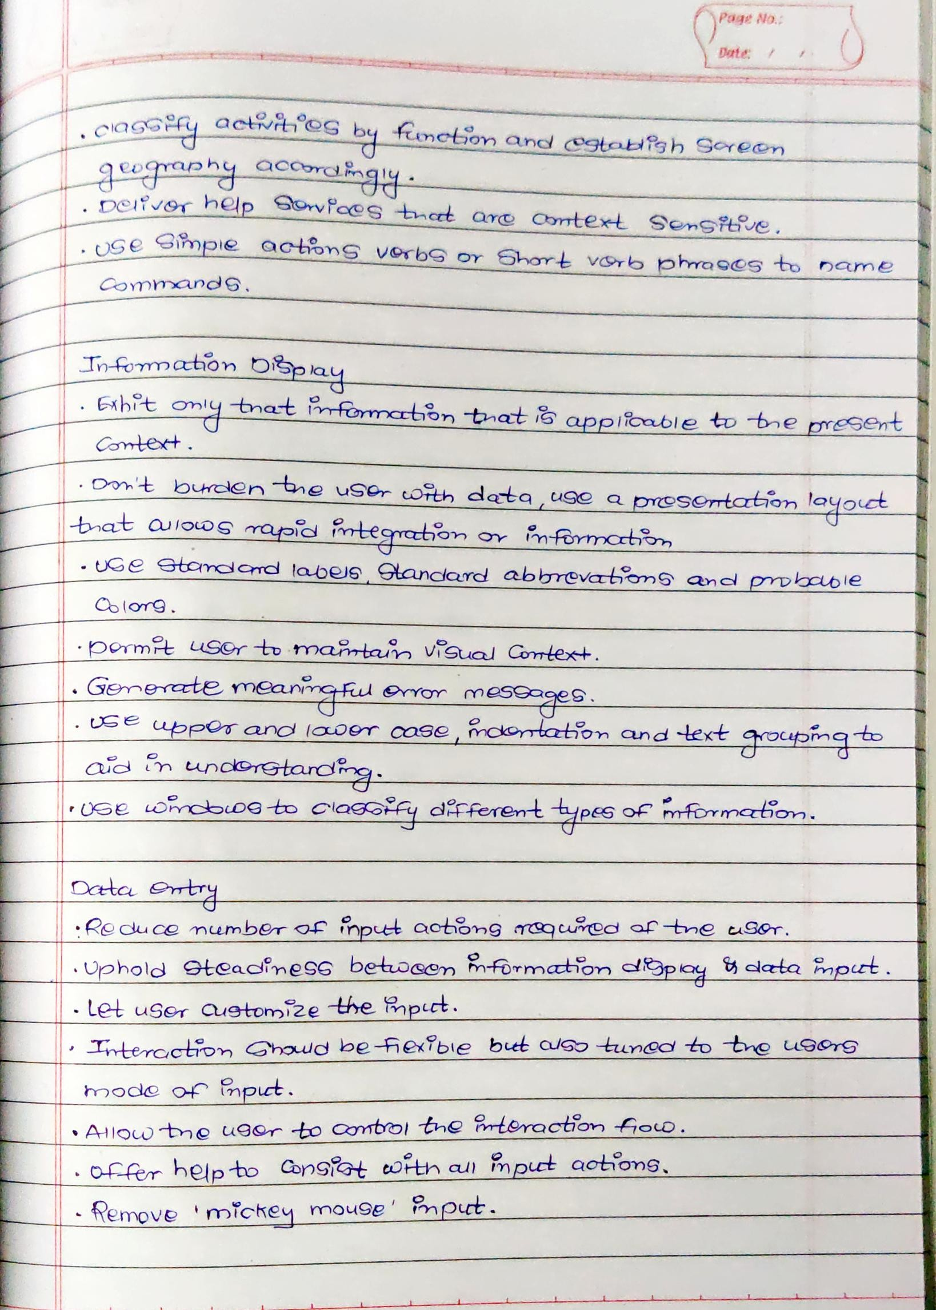

/* Home */

position: relative;

width: 1440px;

height: 882px;

/* Palet 1 / 2 */

background: #FA6648;

/* Header / 1 */

position: absolute;

width: 1440px;

height: 90px;

left: 0px;

top: 0px;

/* Illustration */

position: absolute;

width: 1094px;

height: 882px;

left: 346px;

top: 0px;

/* Content */

position: absolute;

width: 590px;

height: 410px;

left: 115px;

top: 221px;

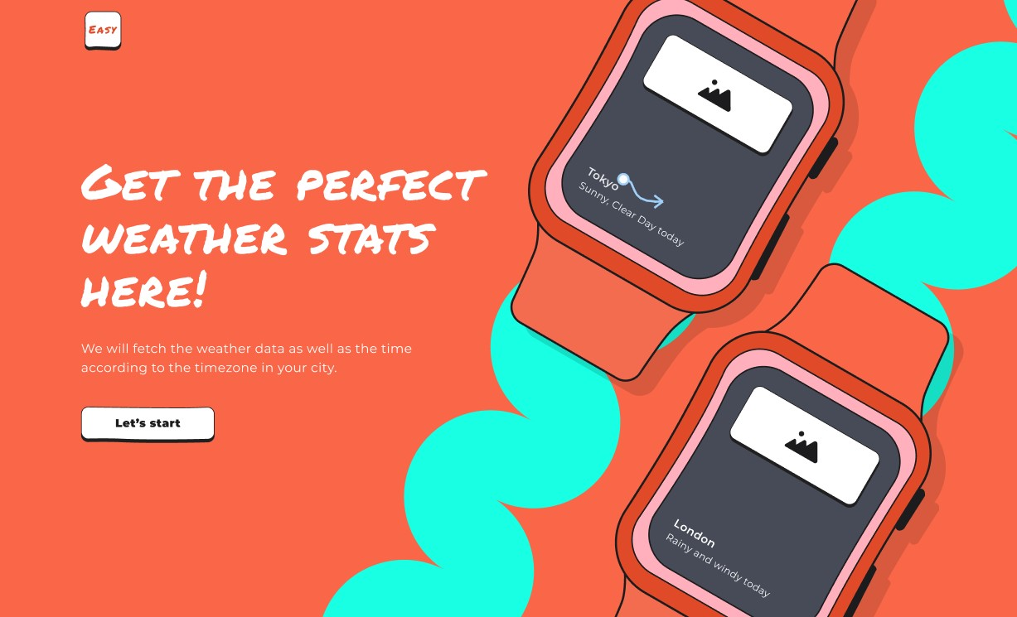

/* Home */

position: relative;

width: 1440px;

height: 882px;

/* Palet 1 / 2 */

background: #FA6648;

/* Illustration */

position: absolute;

width: 808.6px;

height: 710px;

left: 583px;

top: 131px;

/* Content */

position: absolute;

width: 590px;

height: 337px;

left: 120px;

top: 291px;

/* Input Page */

position: relative;

width: 1440px;

height: 882px;

/* Palet 4 / 2 */

background: #2F4793;

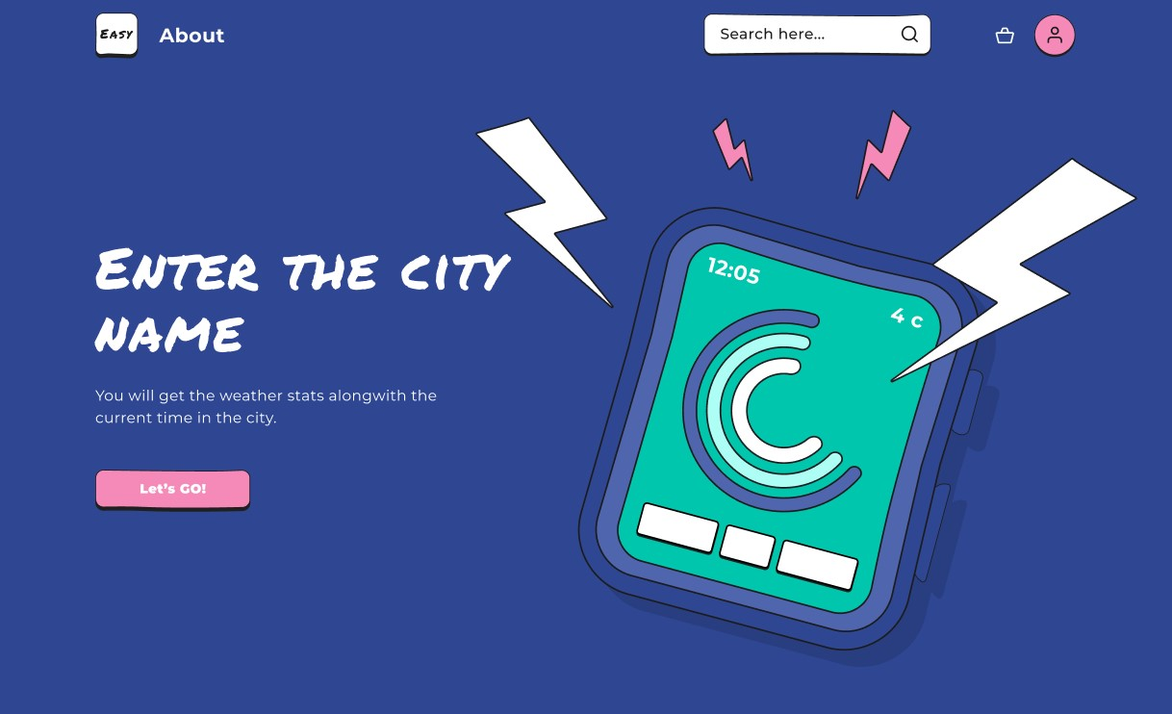

/* Desktop - 1 */

position: relative;

width: 1440px;

height: 882px;

background: #FFFFFF;

/* Frame 18 */

position: absolute;

width: 369px;

height: 100px;

left: 0px;

top: 0px;

/* Group 22 */

position: absolute;

width: 1440px;

height: 351px;

left: 0px;

top: 100px;

/* Group 18 */

position: absolute;

width: 1440px;

height: 159px;

left: 0px;

top: 451px;

/* Group 21 */

position: absolute;

width: 1440px;

height: 272px;

left: 0px;top: 610px;

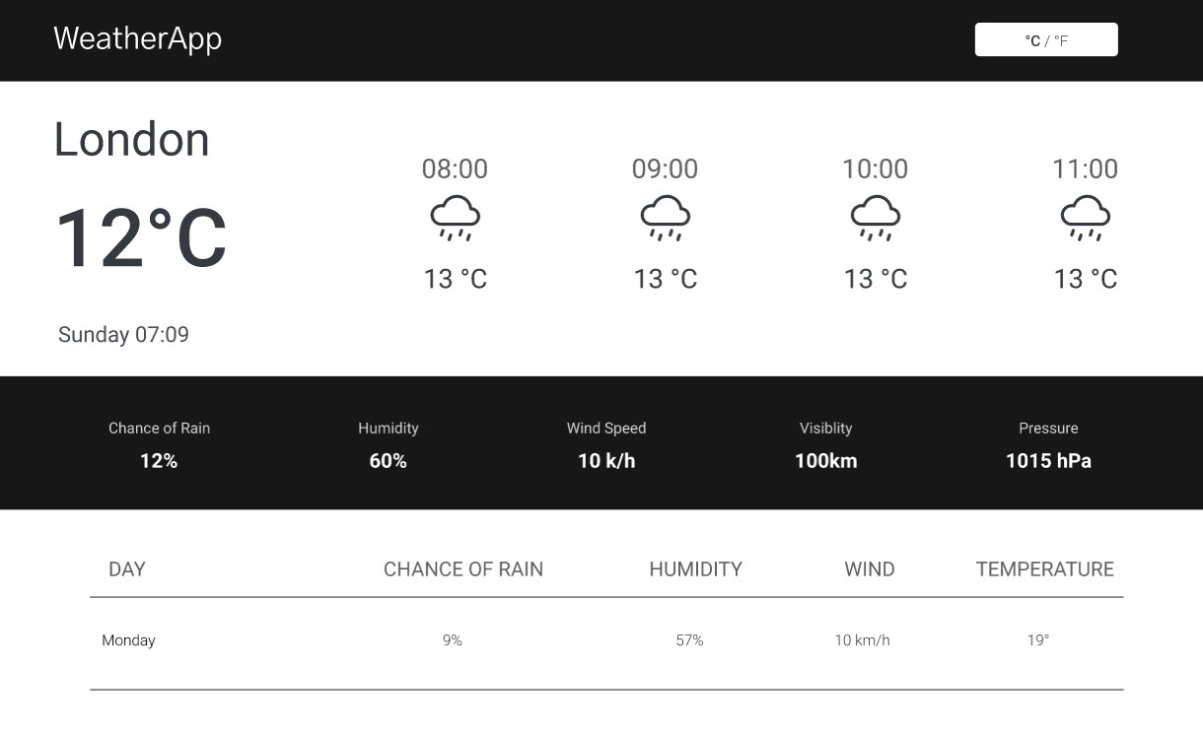

/* About Us */

position: relative;

width: 1440px;

height: 882px;

/* Palet 1 / 2 */

background: #FA6648;

/* Content */

position: absolute;

width: 1244px;

height: 133px;

left: 88px;

top: 97px;

/* Illustration */

position: absolute;

width: 1400px;

height: 882px;

left: 40px;

top: 0px;

/* Cards */

position: absolute;

width: 328px;

height: 279px;

left: 172px;

top: 427px;

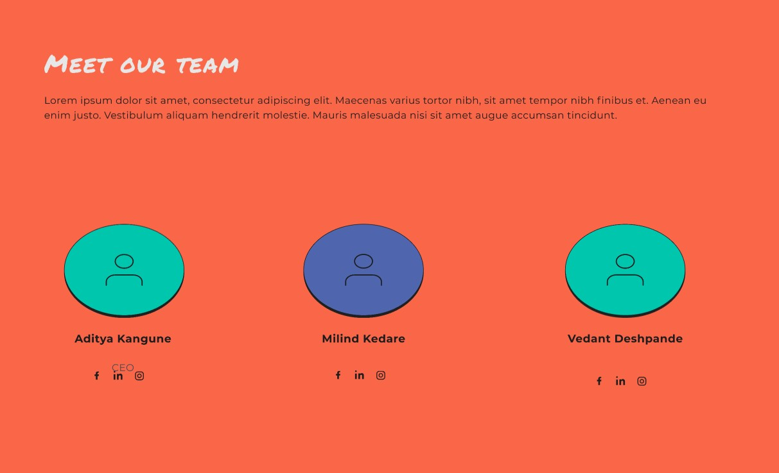

**Conclusion:**

Learnt and Implemented CSS in webpage designing.